roid

217, Sheikh Rashid Building

P.O Box 56272, Dubai

United Arab Emirates

Tel: +971 4 2973236 / 04 2974007

Email: uae@verbat.com

COMMERCIAL   
PROPOSAL

**Exchange of Information on Request System**

|  |  |
| --- | --- |
| **Prepared for:**  **Ministry of Finance** | **Submission Date:**  03 AUG 2018  **Proposal ID:** AD/BP/03072018/1343/1 |

________________________________________________________________________________________________________________________________  
Conﬁdentiality Notice: This Proposal is conﬁdential and contains proprietary information and intellectual property of Verbanet Technologies LLC. Neither this proposal nor any of the information contained herein may be reproduced or disclosed under any circumstances without the express written permission of Verbanet.

© 2018 by Verbanet Technologies LLC. All rights reserved. Confidential.

________________________________________________________________________________________________________________________________

Project Contacts

|  |  |
| --- | --- |
| Client Information | |
| Project Name | Exchange of Information on Request System |
| Client Name | Ministry of Finance |
| Client Address |  |
| Contact Person |  |
| Contact Person Email |  |
| Contact Person Phone Number |  |
| Verbat Information | |
| Contact Person |  |
| Contact Person Phone Number | +971 42973236 |
| Contact Person E-Mail | [darshana.s@verbat.com](mailto:darshana.s@verbat.com) |
| Address | PO Box 56272, Dubai, United Arab Emirates |
| Physical Address | 217, Sheikh Rasheed Building, Hor Al Anz East |
| Project Information | |
| Proposed Technology/Methodology | PHP, Code Igniter, CSS3, HTML5, MySQL, Apache |
| Anticipate Start Date | NA |
| Proposal Valid For | 30 Calendar days from the submission of the proposal |

**Table of Content**

1 Background 6

1.1 Request Registration 6

1.1.1 Baseline System 6

1.1.2 Targeted System 7

1.2 Validation 8

1.2.1 Baseline System 8

1.2.2 Targeted System 8

1.3 Analysis and Allocation 8

1.3.1 Baseline System 8

1.3.2 Targeted System 9

1.4 Response and Preparation 9

1.4.1 Baseline System 9

1.4.2 Targeted System 9

2 Scope of Work 10

2.1 Current System Workflow 11

2.2 Targeted System Workflow 12

2.2.1 Registration Request 12

2.2.2 Validation 13

2.2.3 Analysis and Allocation 13

2.2.4 Response and Preparation 14

2.3 Stand-Alone Fixed Bid 14

2.4 Solution Objective 14

2.5 Advantages of Proposed Solution 15

2.6 Why Verbat 16

2.7 Key Differentiators 17

2.8 Verbat’s Technology & Services 18

3 Functional Specification 19

4 Nonfunctional Requirement (Others) 21

5 Assumptions 21

6 Out of Scope 22

7 Technology Solution 23

7.1 High Level Architecture 23

7.2 Proposed System Environment 24

7.3 Technical Configurations 25

7.3.1 Development Tools 25

7.3.2 Suggested Web Hosting Specification 25

7.3.3 Browser Compatibility 25

8 Commercials 26

8.1 Web Application 26

8.2 Payment Terms 26

8.3 Mode of Payment 26

9 Delivery Management 27

9.1 Project Management 27

9.2 Roles and Responsibilities 27

9.3 Project Implementation Plan 29

9.4 Deliverables 30

9.5 Estimated Delivery Time 30

9.6 Release Planning 30

9.7 Risk and Contingency Planning 30

10 Change Management 32

11 Miscellaneous 33

11.1 Acceptance Criteria 33

11.2 General Terms and Conditions 33

11.3 Assumptions and Dependencies 34

11.4 Source Code & Intellectual Property Rights 35

11.5 Maintenance & Support 35

11.6 Service Level Agreement 36

12 Our Clients 37

# Background

The Exchange of Information (EOI) is the way for Tax Administrations to assess the tax liability of their taxpayers who maintain investments or businesses in other countries. Moreover, EOI are used to detect tax fraud, tax evasion and avoidance and to apply the DTC provisions when a taxpayer claims benefits from a DTC/TIEA and it is needed to verify if such taxpayer is entitled to such benefits. In such cases, countries may ask the treaty partner to provide information through EXCHANGE OF INFORMATION REQUEST (ownership, banking, and accounting (including underlying documents)) about their country resident(s).

This information is held by third parties like Central Bank, Free Zones, taxpayer itself, employer, Departments of Economic Developments, ID Authority, Land Departments, etc.

Currently, the procedure is done manually through (Excel Spreadsheet, Shared Folder, and Shared E-mail address).

## Request Registration

### Baseline System

Registration requests involve the following actions:

* Capture information in Excel: The information captured consists of
  + Date of receipt
  + UAE reference number to the request
  + Requesting country name
  + Legal basis of the request
  + Date that is requests received
  + Foreign reference number
  + Date the request was made by the foreign partner
  + Urgency of the request
  + Name of the under investigation tax payer in the UAE
  + Type of tax
  + Years under investigation
  + Type of information requested
  + Status: Registered
* Shared folder for storing Request: This step involves the following steps
  + Scan the request
  + Save the scanned file with a UAE reference number
  + Store the file in EOI shared folder
* E-mail: Send acknowledgment of receipt via email to requesting country with UAE and foreign country reference number.

### Targeted System

The targeted system shall innovate the existing manual process by

* Capturing the information using a Web Form.
  + Additionally capture payment or transactions being investigated, intermediary banks linked to the information (Name, A/C # Branch etc.)
  + Additional Relevant back ground information with reason for enquiry, civil or criminal,
* Information may instead be uploaded into the portal using a predefined document template
* The information captured shall be digitized and converted to a PDF information if necessary and stored as a Flat File on BLOB Storage
* Upload formal documents related to the request (bank records, tax records, evidence documents)
* An acknowledgement email shall be send to the requesting country with a UAE reference number

## Validation

### Baseline System

In the current system the validation is done offline. No indication has been given whether this process involves cooperation between inter agencies.

### Targeted System

Targeted system shall have capabilities to integrate with various UAE government departments to verify

* Identity of the individual being investigated (Name, DOB, Marital Status, Known addresses, TIN etc.)
* Bank Accounts affiliated to the individual
* Investment accounts affiliated to the individual
* Affiliations to corporate or legal entities
* Criminal or Civil records

Validation shall be a Multi-step process that provides information to the investigator on the nature of investigation being conducted. The Investigator shall have various prompts to indicate the status and state of investigation.

## Analysis and Allocation

The Validation step automatically validates various pieces of information that were being requested. Not all elements can be verified or validated automatically, hence the analysis and allocation step involves the manual analysis of the packets being sought

### Baseline System

The baseline system follows the process listed below

* Identify the concerned UAE stakeholder
* E-mail: Fill Excel Sheet template of the concerned UAE entity and send the request with the filled template attached to the concerned entity.
* Excel Sheet: register the UAE entity the request of information sent to, the date the request was sent, change status to “Request sent to third party”

### Targeted System

The proposed system shall automate this process by

* Determine the information packets that needs to be investigated upon and identify the concerned UAE stakeholder who is the custodian of the information
* Create offline and online requests based on appropriate templates
  + Offline requests are printable PDF/word/spreadsheet documents (generated by the application) that shall be snail mailed to the custodian
  + The generated documents may be emailed (inline) to the custodian
* Log and register the information request with a trackable status that can be updated to determine the state of the request

## Response and Preparation

### Baseline System

Base line state of the current system is described below

* Response is received through email.
* Excel: Status update (Received from 3rd party, partial response, Closed”
* Shared Folder: Save the received response in the concerned file, Print the response as attachment and prepare the cover letter (template), scan it and save a copy in the concerned file.

### Targeted System

The targeted system shall provide an interface assimilate the information requested. Depending on the nature of the request, the custodian shall have an interface by which they can update the information requested. The steps involved are; listed below

* Based on the nature of the request, an appropriate form shall be available to the custodian to log the information requested
* Additional documents requested or documents that support the information provided shall be uploaded by the custodian
* The documents uploaded shall be tagged and stored so as to be available for future reference.
* The documents shall be tagged against the request for easy access
* The status of the request shall be updated
* A cover letter shall be composed electronically based on a predefined template
* The letter along with all documentary evidence shall be emailed as attachments to the country that made the request and the request shall be closed with an appropriate status

# Scope of Work

The scope of work is to implement a system that fulfills the requirements for MoF’s exchange of information. The proposed system shall be safe, secure and allow adequate privacy and protection of data and correspondence. Furthermore, the solution shall allow for effective management and documentation of tasks and correspondence, with the necessary reminders and alerts for action for all parties.

The system must allow effective collaboration, whilst maintaining integrity of information. The system must be easy to use and provide a rich user experience.

## Current System Workflow

## Targeted System Workflow

### Registration Request

The country representative has three options to fill in the form

1. Fill in the web form like you normally would in any web application OR
2. Attach the requested information based on a standard Excel template being provided to them. The system will parse the data in spread sheet and save the information in the database. The attachment itself shall be saved separately for future reference OR
3. Simply mail it as an attachment to a predefined email address. The email may have one or more attachments. Using Robotic Process Automation (RPA), the email along with its attachments will be processed and the data will be entered into the web application just as a human user would. The RPA Shall also save the attachments in a predefined location or in the database (depending upon the implementation)

Depending on the mode used for filling out the application, the system will process the information and save it in the database. All attachments will be stored in the database as a BLOB object. Email and SMS notifications shall be send on the receipt of the request

### Validation

In this step, the system shall interface with other government entities to request and validate the information requested. This can be accomplished by

1. Using web API’s provided by government agencies to validate the identity, background etc. of the requested entity OR
2. Using RPA; whereby if the government agency has a standard web based request form for the information being sought, the RPA shall access these pages and fill in the required information to request data needed for validation (Just like a human user would)

Note: Implementations using RPA are exponentially faster and cheaper than traditional web based implementations. However RPA does not fit into use cases where a business process has not been established. If business processes are well established and well defined, then an RPA solution may completely obliterate the need for a traditional implementation (i.e. to implement the business process by developing web based or desktop based applications). RPA does require a thorough understanding of the business process before it can be put into practice.

### Analysis and Allocation

Predefined templates shall be available to request information. They are of 2 types

1. Depending upon the context, email templates shall be created. These predefined templates shall be used for inter-agency communication
2. Predefined Excel templates shall be created to store additional information related to a request.

The application shall sent emails with attachments to other agencies to retrieve targeted information. The system shall save the status of the information requested along with any pertinent details that it receives following the request.

### Response and Preparation

Once all of the information has been assimilated or if the investigation has reached a point where it cannot ascertain the details of the requested information, a report shall be created. This report shall be send to the Requesting Authority of the country that made the request.

## Stand-Alone Fixed Bid

Verbat will be following a stand–alone fixed bid solution delivery model wherein the required solution would be devised and a suitable pricing would be offered.

## Solution Objective

Verbat’s Solution architects have conducted a thorough research on the requirements and have come to the conclusion that our proposed solution, which is detailed further in this document, will meet the requirements put forth by the client. And the proposed solution will be delivered in a phased approach as per Verbat’s stand-alone fixed bid solution model.

**Strong and Scalable platform:** The platform proposed will be strong and scalable enough to accommodate future enhancements.

**Accelerated solution:** The framework would act as a solution accelerator. It would provide the basic building blocks which could be reused in future for building new components and features.

**High performance:** The light weight framework used consumes fewer system resources thereby making the application perform faster.

**Security:** The application will be developed considering various aspects of security.

## Advantages of Proposed Solution



01

Agile development offering reliable, secure solution

02

Smooth transition and quicker completion of processes

03

User friendly interfaces enabling easy navigation between screens

## Why Verbat

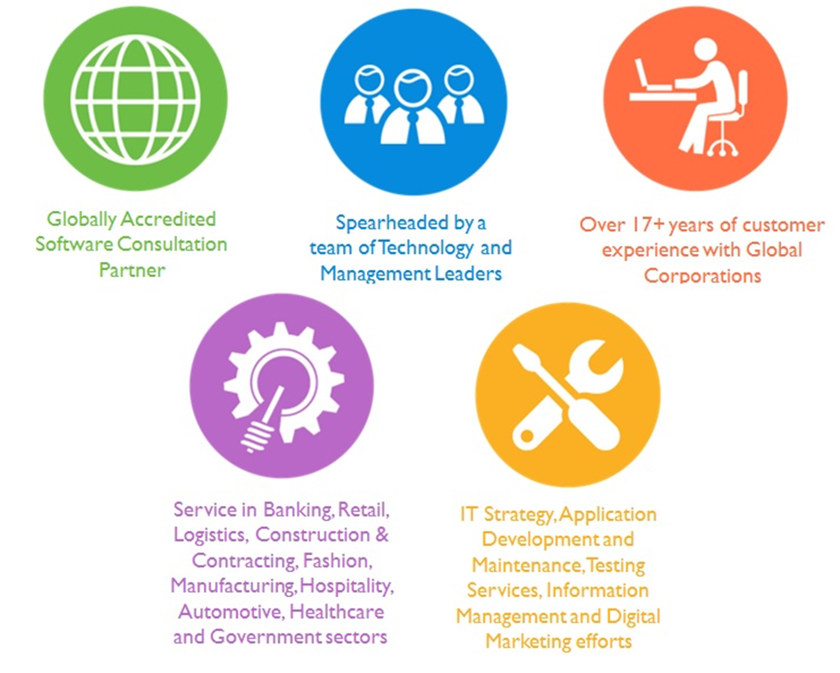

## Key Differentiators

Delivered digital transformation expertise to global customers for over a decade by following industry best practices to maximize ROI for client

Keen technology intelligence combined with aggressive market research to deliver solutions that achieve results with measurable value

Enable access to global consulting expertise with strong local market and business knowledge

Commercial Model that is customizable for your business needs

Services that are designed to optimize applications for improved performance and overall efficiency

1,000,000 plus man-hours of expertise in technology frameworks spanning Microsoft, Open Source, mobility platforms and other proprietary IT technology

Partners top technology vendors to bring in the latest and best services in integration, collaboration, and development

Commercial Model that is customizable for your business needs

Proven Methodologies & Processes

Investment in R & D

Strong Local Presence

Flexible commercial Models

Technology Associations

Software Development Experience

Offshore Development Centre

Quality Assurance & Testing

## Verbat’s Technology & Services



Technology  
&  
Services

Cloud/Traditional Hosting

User Interface & Design

Digital Marketing

Mobility Solutions

Testing Services

Application  
Development

# Functional Specification

Figure Overall Workflow

|  |
| --- |
| **Development** |
| Application Basic Setup |
| **Admin** |
| Master Data (Legal Basis of Request, Countries, Request Urgency, Type of Tax, Type of Information requested, Status, UAE Stakeholders: emails) |
| Manage Application Users |
| **Registration Request** |
| Registration Request Form |
| Parse template Documents (Simple Spread sheet with a single tab, no formulas or special formatting that might hinder data retrieval) (optional) |
| RPA Implementation |
| SMS & Email; Request receipt |
| Save documents |
| Save status |
| **Validation (All activities Optional)** |
| Verify and Validate Data |
| RPA Implementation |
| Validation checklist |
| Update status |
| **Analysis & Allocation** |
| Generate Document from template |
| Generate Email from template |
| Create forms for agencies to respond |
| Email notifications |
| Status updates |
| **Responses & Preparation** |
| Generate main report for requestor |
| Other reports |
| Compose Email from template & attachments |
| **System features** |
| Authentication & Authorization |
| Auditing & logging |
| Exception handling |
| manage email templates |
| Manage Excel Templates |
| Document management |
| Email & SMS |

# Nonfunctional Requirement (Others)

|  |  |
| --- | --- |
| **Requirement** | **Details** |
| User Experience and  UI Design | * The application will be developed only in English * The layout and graphical components will be created considering the usability factors |
| Performance | * Application will allow users to have smooth and quick access to the information or services they require. |
| Security | * The system will be protected against attempts of security breaching that may arise. * Web security standards will be followed. |

# Assumptions

The project solution and technology is created from the initial understanding of the requirement shared with Verbat through mails and meetings. The proposed solution is based on the following assumptions:

* Client to provide Verbat with the branding guidelines.
* The proposed application will be in English
* Client will purchase the necessary themes needed for development
* Client shall provide licensed images and logos in specified size & format
* Requirements should be well defined, agreed and signed-off by the client
* Internet connectivity is required for the functioning of the web application.
* Development Contingent upon timely feedback from client
* Application shall be responsive only for web and tablet browsers
* RPA Tool purchase cost has not been included in the cost
* Effort estimated for the integration of a single third party API
* Templates are predefined. Application shall not provide ability to design and generate templates
* Cost includes the development of 1 basic report
* Client shall provide implementation details for all integrations

# Out of Scope

Following are considered to be out of scope while creating this proposal.

* Purchase of images, fonts
* Adding new features to the application other than mentioned in the functional specification.
* Any language other than English
* Manual data entry
* Hardware Integrations / procurement and purchase
* Database migration
* Content writing
* Content or image procurement or uploading or editing.
* Annual Maintenance of the application (Bug fixing, debugging) - For AMC details, please refer section titled “Maintenance and Support”
* Physical deployment at client’s site
* Backup solution and Disaster recovery
* Payment gateway integration

# Technology Solution

## High Level Architecture

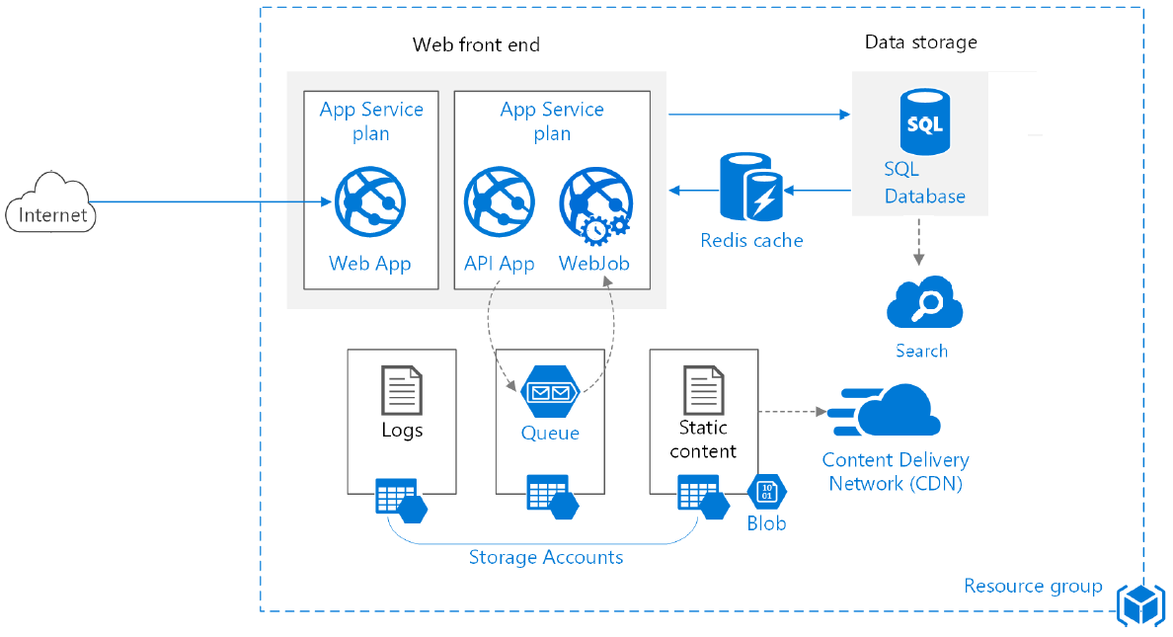

## Proposed System Environment

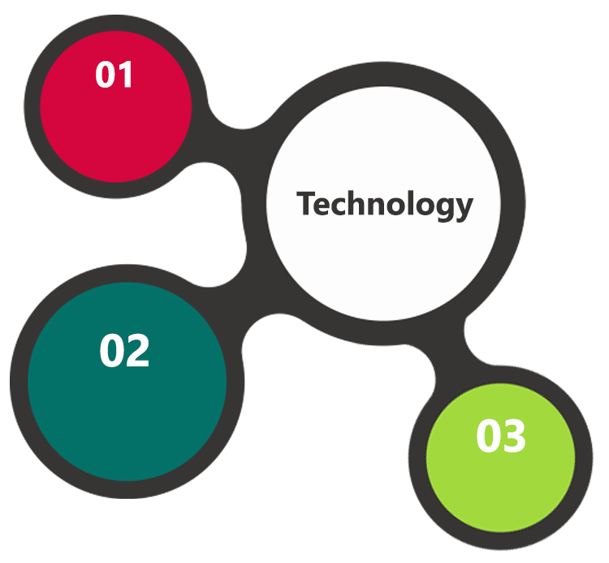

C#/.Net MVC

UIPATH

MSSQL/IIS

HTML / CSS3/ JQuery

**MS SQL2012  
Windows 8/10  
Web Services**

## Technical Configurations

### Development Tools

* C#, .Net MVC
* MSSQL, IIS
* UIPATH
* HTML5 / CSS3
* Ajax, JavaScript, JQuery

### Suggested Web Hosting Specification

* Windows Dedicated server
* 8 Core CPU
* 16 GB RAM
* 1 TB HDD
* Windows OS or Linux OS, MySQL Server
* IIS With Apache or APACHE for Linux

### Browser Compatibility

* Chrome version: 56
* Firefox version: 51
* Edge version: 39
* Safari version 10.1

# Commercials

## Web Application

|  |  |  |
| --- | --- | --- |
| **No** | **Description** | **Amount (USD)** |
| 01. |  | 00,000.00 |
|  |  |  |

*Note:*

* *For change management cost, please refer to section 10 titled Change Management*

## Payment Terms

*Note: Payment should be made within 7 days from the date of the invoice*

## Mode of Payment

By Cheque / DD to Verbanet Technologies LLC

OR

Wire transfer to our bank account

Bank Name : Emirates NBD

Account Name : Verbanet Technologies LLC

Account Number : 1011492858201

IBAN Number : AE61 0260 0010 1149 2858 201

Swift Code : EBILAEAD

Bank Address : Mamzar Branch, Dubai

*Note: Bank charges incurred during wire transfer to be borne by the client. Any local taxes applicable to be borne by the client*

# Delivery Management

## Project Management

The Verbat development center strictly follows industry standards on quality. The project management is process governed by the Verbat Quality Management system and is put to verification through internal audit programs that happen from time to time.

Verbat will dedicate a project manager for the proposed implementation. Verbat proposes Client to identify one project manager who will be driving activities to be undertaken by Client to be the single point of contact for Verbat.

## Roles and Responsibilities

Verbat will assign a dedicated Project Manager/Project Lead to lead the project, who will be the first point contact for Client. He/she will be responsible for planning and managing the various activities within the project. He/she will work closely with Client Project Manager, to give periodic status updates and ensure high level of visibility and comfort on the progress of the project.

The Project Manager/Project Lead will lead the co-ordination between Verbat and Client, thus enabling smooth transitioning of Client requirements to the Verbat’s offshore delivery team, and provide visibility as well as comfort on the progress of the services to Client.

He/she will have periodic meetings with Verbat’s Senior Management, thus ensuring Verbat’s Management commitment and focus on Client initiatives.

Delivery Activity Summary

|  |  |
| --- | --- |
| Activities | Description |
| Detailed requirement Analysis | Verbat team to conduct detailed study of requirement for the phase. If clarification is required, team will reach out to Client for more information and/or time for discussions. |
| DB Design | DB design for central and test DB. |
| Software Requirement Specification document (SRS) | Once the requirement analysis is completed, Verbat team will submit the SRS document for approval |
| UI/UX Design, Prototyping | Based on the SRS, Verbat UX/UI team will work on the UI/UX of the screens and submit a prototype for approval |
| Functional Specification Document (FS) | Once the Prototype. UI/UX is approved, Verbat shall submit an FS document for approval. |
| Development | Actual system development starts based on the FS. This involves detailed design and software development of Web/Mobile Application. |
| Testing | Test Planning, test plan creations, internal, integration testing and user acceptance testing. |
| Deployment | Deploying the latest built in the Verbat Test Server. |

## Project Implementation Plan

Verbat will be providing the solution in a stand-alone fixed bid approach which ensures minimum viable solution for quick wins with core focus on the long-term business objective and outcome. Once the implementation is over, Verbat will initiate the application maintenance process (once the maintenance contract is signed) which continues to extend after the implementation.

## Deliverables

* Design templates (Web & Mobile)
* SRS
* Prototype of the application
* Test cases
* Source Code
* Fully Developed & Tested Application (Web, iOS and Android Mobile App)

## Estimated Delivery Time

The effort estimated for delivering the application is as follows;

* Delivery of Prototype: 3 Working Man Days
* Days for the development of the application from the Date of Approval of the Prototype: 30 working man days

## Release Planning

* Client will be informed about the release date and time through email.
* Client performs the UAT

## Risk and Contingency Planning

Verbat has identified various risk factors associated with this assignment and understands the impact of these risk factors on the project schedules. The objective of this section is to highlight for both Verbat and client, the risk factors, to analyze the impact of the risks on project execution, and to propose strategies to control and reduce the impact of the risk factor.

These various risks, which could arise during the project, are tabulated below along with mitigation implementation.

| Type of risk | Impact | Risk Mitigation | Risk Handling |
| --- | --- | --- | --- |
| Scope Creep | H | Functions and features will be detailed in system requirement documents and will go through client approval. Once this document is approved, any change to requirement will go through change management review for possible impact assessment. | Proper change management procedure will be implemented. |
| Delay in customer feedback | H | The plan is prepared with enough lead-time for customer reviews and approvals.  The customer is indicated with the dates when the document is expected after review and approval. | The request for feedback will be escalated if not attended at the right time so that the schedules are not affected. Deemed acceptance criterion is set up front and will be followed. |
| Non-availability of necessary software’s, frameworks, database instances and infrastructure at client’s hosting environment(If hosting support is provided by Verbat) | M | Client will be informed in advance on these requirements. | Possible impact to schedule. |
| Manpower attrition | L | All efforts would be made to ensure process dependence rather than being person dependent. As a risk mitigation plan Verbat will train backups. | A new person will be identified as early as possible, provided the required project-specific training and mentored by the senior members of the team to minimise impact of attrition on the project. |

*H-High, M-Medium, L-Low, NA-Not Applicable*

# Change Management

Any addition which comes out of the project scope, upon and after the launch of the tool will be considered as change management. Verbat recommends the following change management procedure for the same.

* Any change which comes out of the project scope, which was discussed, documented, and mutually approved by both the parties in the requirement stage, will be carried out only through raising a change request.
* Change request will be studied and an impact analysis on the existing work flow will be performed.
* On finalizing the impact, effort estimation for the change will be calculated and raised as additional requirement.
* Verbat will initiate the change request only after getting a formal approval from the client for the additional changes raised.
* Any change from the scope will be charged at **USD ----- per man day effort** and approval from the clients will be availed before commencing on any change management.

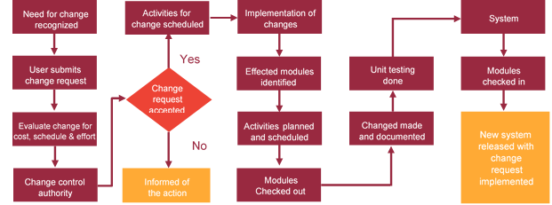

# Miscellaneous

## Acceptance Criteria

* UAT sign off should happen within 14 Days from the release of the application/ Phase and the acceptance confirmation needs to be mailed to Verbat failing which Verbat will consider the project as approved by the client.
* Any comments or reason for rejection need to be documented and the same needs to be sent as an email from the official mail id of client to Verbat.

## General Terms and Conditions

* All the projects activities will be carried out from our off-shore development center in India
* The scope of the project is to develop the Application as detailed in the scope of the project and mentioned in this proposal. Any changes or additions will have to go through change management.
* This proposal and all technical/ functional specifications have been derived or concluded from the data shared via email / information's transferred during the initial requirement analysis meetings and conversations. Verbat reserves the right to amend the terms of this proposal, should the SOW terms, functional features and functionalities change during the course of the project
* Application will be best viewed only in the environment mentioned in this document
* All the documentation will be provided in English.
* Third party components may be used to develop this application.
* All Source Code and other project artefacts would adhere to the Verbat document templates and internal coding standards
* Client shall provide the respective enterprise apple store and Google play store accounts for development and production
* Acceptance criteria shall be based on the clauses which were mutually discussed between Verbat and client at the Requirement Analysis phase and the same will be documented and approved by both parties through official emails
* In case Client requires any extension of the proposed acceptance schedule, the associated effort and cost of such extension can be mutually reviewed.
* For any circumstances if project needs to be put on Hold / Stop it requires minimum request notice period of 2 weeks along with duration for which request will be addressed by management and final decision on the request will be based on that
* If deployment is done in client’s server, Verbat cannot be held responsible for any performance issues arising due to hardware malfunctions.
* Source code will only be delivered or uploaded on the Production Server once the due payments are made.

## Assumptions and Dependencies

* Detailed system study is required before the start of the project.
* During the requirement gathering phase, authorized personnel from the Client’s side is expected to be available for discussion and finalizing the HLD (High Level Design), before development commences.
* Type of reports and formats, if under the scope of the project, needs to be specified by Client before project sign off.
* Workflows if under the scope of the project, need to be specified/ confirmed by client before project signoff.
* All queries regarding the client requirement and any queries which may hinder the project advancement at any stage should be answered by the client within 24 hours from the time of initiation, failing which the time delay will get added to the actual effort which was estimated.
* Verbat assumes that all sign-offs from Client will be provided within agreed and specified timeframe.
* Client will provide all the necessary contents, both text and image, before starting the project in the format suggested by Verbat (if any).
* The client should provide the relevant information and data well in time for the execution of a related activity. Non- availability of this information or data may lead to an interruption of work which may result in a delay in delivery as well as additional costs to the client.

## Source Code & Intellectual Property Rights

* Upon completion of the Project and 100% completion of the payment, client will have access to the source code except for propriety codes, developer tools and third party application etc.
* The solution offered will be the intellectual property of the client and will be made available to the client on an “unlimited license” basis.
* Modifications by third party/person: No person or organization, other than Verbat or any person authorized by Verbat in writing, has any permission to modify/change the software Solution to be eligible to get continued support from Verbat as per the support terms defined under this document.
* Liabilities/Damages: Verbat accepts no liability or damages of any kind arising out of use or non-use of the software delivered. The responsibility of testing of software lies with Client.

## Maintenance & Support

* Maintenance contracts by default are supported as per the basic SLA terms.
* **AMC with Basic SLA is charged at 20 % of the total project value**. Additional Effort/change management request will be added towards Total Value of the Project to determine the AMC value.
* Maintenance support is limited to providing application support for ensuring the consistency of the look-and-feel, bug fixes and user issues i.e. maintenance and support of the existing features of the application.
* Support does not in any way cover providing technical or other support to the end users. The maintenance agreement does not include functionality changes or feature additions which are handled as change requests which will be charged AED 1200 per man day. AMC does not include server support, maintenance and application deployment.
* AMC charges will cover Off-Site Support and Debugging. Support includes E-mail, Telephone and Chat unless explicitly specified. In the event, the application is hosted with the client; necessary remote desktop connectivity should be provided for carrying out maintenance activity.
* Gap in AMC - In case if the client does not opt an AMC for a year and want to renew it after that period, 50% of the AMC amount for the year for which AMC is not taken will also be payable if the client wishes to renew the AMC contract.
* Note:
  + Please note that the AMC support shall start only after all the necessary sign-offs (AMC Document) to this effect have been given.
  + It is not mandatory that the client should opt for an AMC. The client will still be supported on an ad-hoc basis on an agreed man-day rate.
  + AMC Payment Terms: 100% to be paid as advance.

## Service Level Agreement

|  |  |  |  |  |
| --- | --- | --- | --- | --- |
| **Key** | **Max Response Time** | | **Max Resolution Time** | **Target** |
| Basic | 1  working day | 3 working days | | Request / incident / problem tickets |
| Advanced | 5 Business Hours | 12 Business Hours | | Request / incident / problem tickets |
| Priority | 3 Business Hours | 5 Business Hours | | Request / incident / problem tickets |

Note:-

* We provide Basic SLA as standard with AMC while Advanced and Priority SLAs attract additional charges.
* Time zone applicable as per India time zones (3:30 AM GMT to 12:30 PM GMT- Monday to Friday).

# Our Clients

**UAE University**

Education

Transportation

**Canada Cartage**

Construction

Services

Finance

We look forward to hearing from you soon and hope that you will give us the privilege to work with you in meeting your business goals. Thank you.

Thank You



©   
1999 - 2018. All Rights Reserved   
Verbanet Technologies LLC  
www.verbat.com